

# NATIONAL UNIVERSITY OF SCIENCES AND TECHNOLOGY

SCHOOL OF MECHANICAL AND MANUFACTURING ENGINEERING

MECHANICAL ENGINNERING (ME-15)

# PROGRAMMING:

Assignment # 1;

**SUBMITTEED BY: MUHAMMAD ALI SHOUKAT**

**REGISTRATION NUMBER: 457397**

DATE OF SUBMITTION: 23rd of November, 2023

* **Task 1:  
  statement:** write a c++ code to display the factors of given number using for loop.

**Solution:**

**Code:**

#include<iostream>

using namespace std;

int main(){

int n;

cout<<"enter your desired integer to find its factors";

cin>>n;

cout<<"factors of "<<n<<" are "<<endl;

for(int i=1;i<=n;i++){

if(n%i==0){

cout<<i<<endl;

}

}

return 0;

}

**C++ file:**





**Output:**

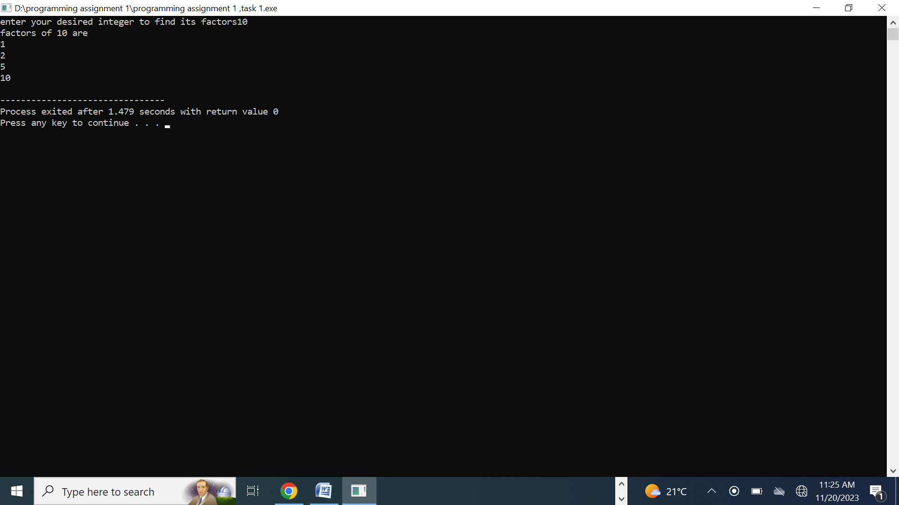

=

* **Task 2:**

**Statement:** write the output of following code:

#include<iostream>

int main(){

int x=5;

int y=7;

If(x==50)

If(y==7)

std::cout<<” x is 5 and y is 7”<<std::endl;

else

std::cout<<”x is not 5”<<std::endl;

return 0;

}

**Solution:**

**C++ file:**





**Output:**

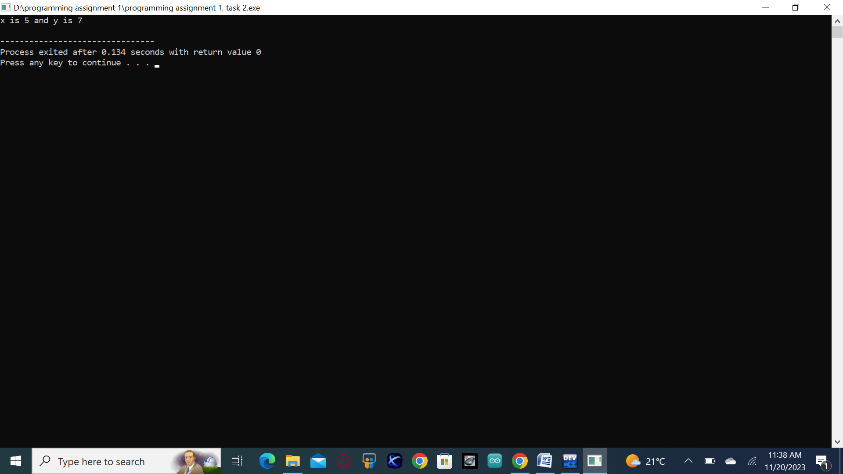

* **Task 3:**

**Statement:** write a c++ program that take an integer from the user an input and check if it is greater than 10 and less than equal to 20. Print 1 if yes and 0 if no, use appropriate data type for output.

**Solution:**

**Code:**

#include<iostream>

using namespace std;

int main(){

int num;

cout<<"enter your desired number there"<<endl;

cin>>num;

if(num>10 && num<=20){

cout<<"1"<<endl;

}

else{

cout<<"0";

}

return 0;

}

**C++ file:**





**Output:**

* **Task 4:**

**Statement:**write a c++ program to find the largest prime number less than or equal to a given integer **N**, where **N** is input from user. This should be done by using while loop and without using any library or predefined function.

**Solution:**

**Code:**

#include<iostream>

using namespace std;

bool isprime(int n);

int main(){

int num;

cout<<"enter your desired number ";

cin>>num;

while(num>=0){

if(isprime(num)){

cout<<"the largest prime number less than entered number is "<<num;

break;

}

num--;

}

return 0;

}

bool isprime(int n){

for(int i=2;i<=n/2;i++){

if(n%i==0){

return 0;

}

}

return 1;

}

**C++ file:**





**Output:**

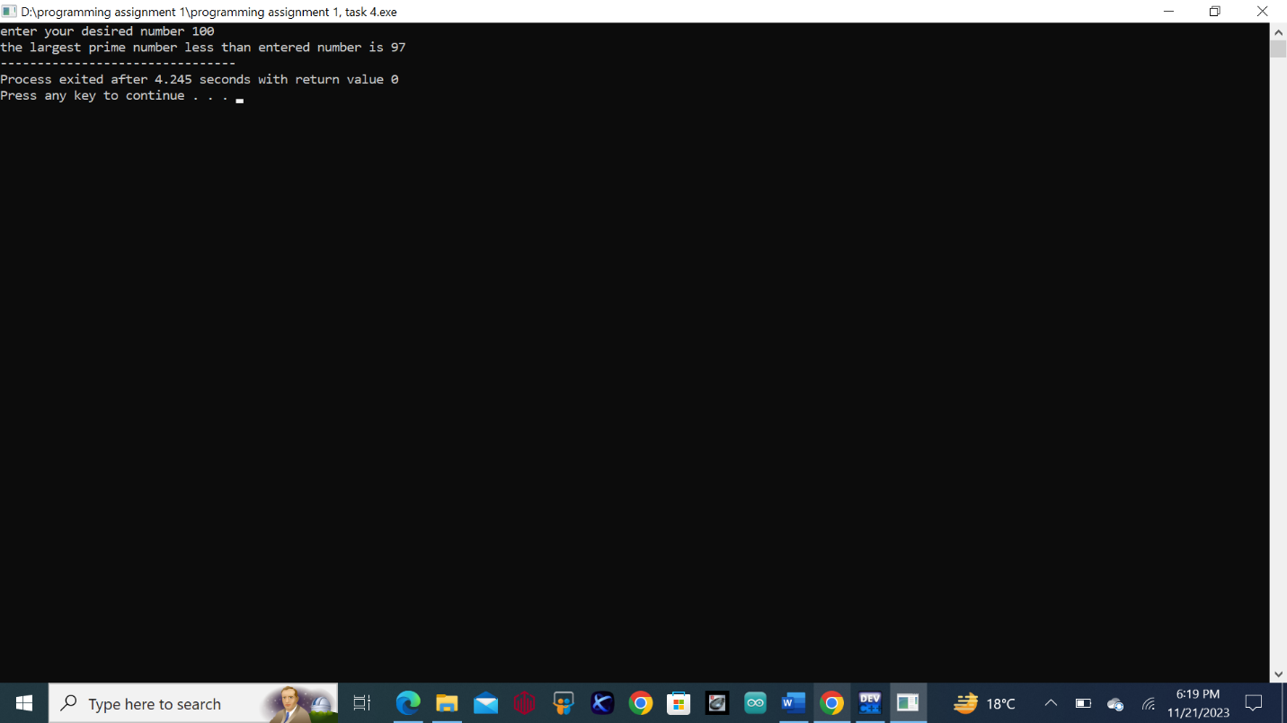

* **Task 5:**

**Statement:** write a c++ program to check whether the two strings are equal or not. If they are equal reverse the string, for example hello must be reversed into olleh. **Solution:**

**Code:**

#include<iostream>

using namespace std;

int main(){

int n;

cout<<"enter the number of elements for string"<<endl;

cin>>n;

char str1[n],str2[n];

cout<<"enter the elements in first string "<<endl;

for(int i=0;i<n;i++){

cin>>str1[i];

}

cout<<"the original entered string is ";

for(int i=0;i<n;i++){

cout<<str1[i]<<" ";

}

cout<<"enter the elements in second string "<<endl;

for(int j=0;j<n;j++){

cin>>str2[j];

}

cout<<"the original second string is "<<endl;

for(int j=0;j<n;j++){

cout<<str2[j]<<" ";

}

for(int i=0;i<n;i++){

if(str1[i]==str2[i]){

cout<<"both strings are equal "<<endl<<"the reversed string is "<<endl;

for(int k=n;k>=0;k--){

cout<<str1[k]<<" ";

} return 0;

}

for(int i=0;i<n;i++){

if(str1[i]!=str2[i]){

cout<<"both strings are different ";

} return 0;

}

}

}

**C++ file:**





**Output:**

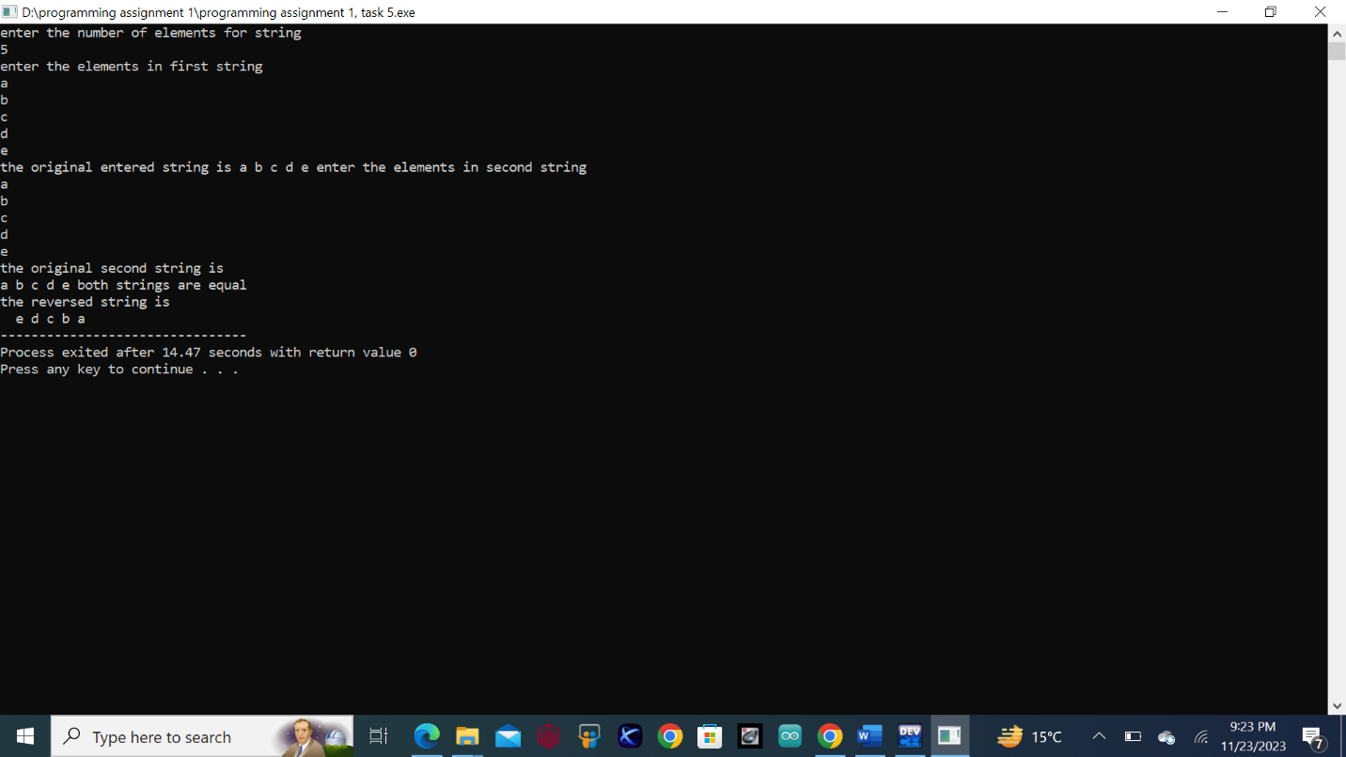

* **Task 6:**

**Statement:** Perform division in C++ without / using for loops. You can use / only to display the final results. Your dividend must be greater than divisor. **Solution:**

**Code:**

#include<iostream>

using namespace std;

int main(){

int dividend,divisor,qoutient,remainder;

cout<<"enter the number to be divided (must be greater than divisor) ";

cin>>dividend;

cout<<"enter the number to divide the dividend ";

cin>>divisor;

qoutient=dividend/divisor;

remainder=dividend%divisor;

cout<<"the qoutient is "<<" "<<qoutient<<endl<<"the remainder is "<<" "<<remainder;

return 0;

}

**C++ file:**





**Output:**

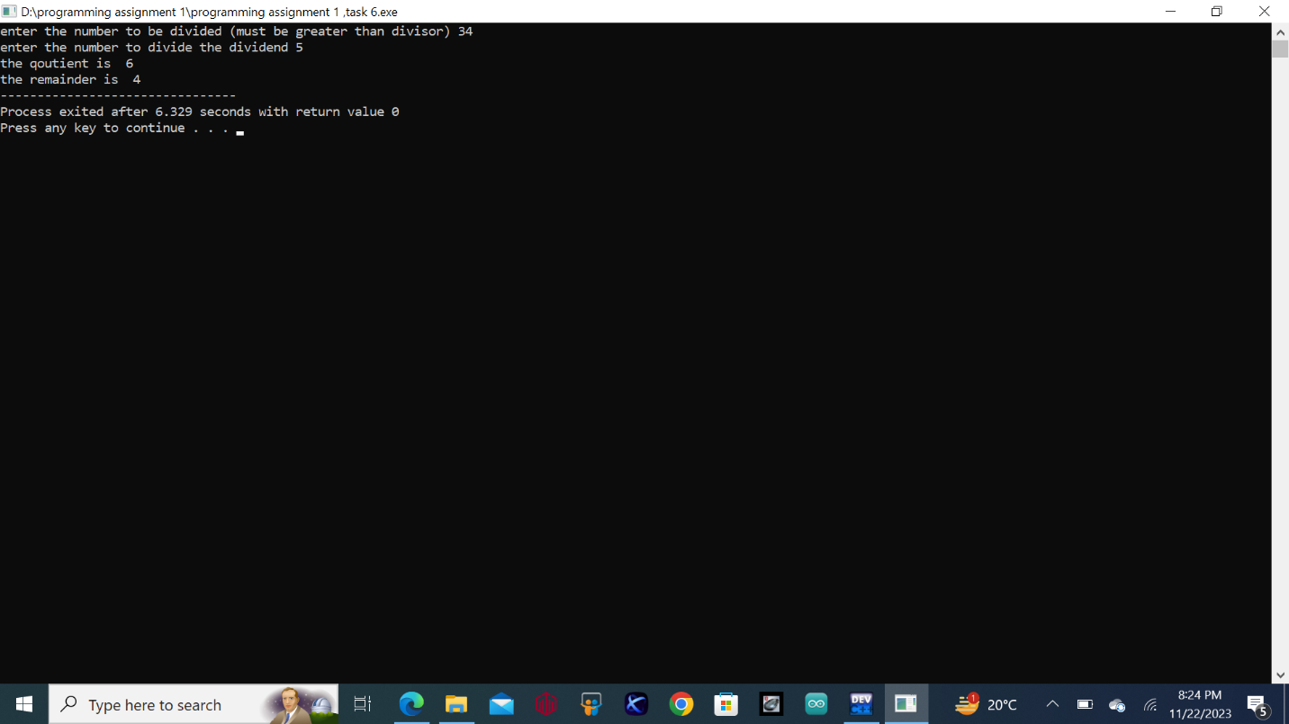

* **Task 7:**

**Statement:** Write a C++program for a string which may contain lowercase and uppercase characters. The task is to remove all duplicate characters from the string and find the resultant string

**Solution:**

**Code:**

#include<iostream>

#include<string>

using namespace std;

int main(){

string st,result;

bool fop;

cout<<"enter string: ";

cin>>st;

for(int i=0;i<st.length();i++){

fop=false;

for(int j=0;j<result.length();j++){

if(st[i]==result[j]){

fop=true;

}

}

if(fop==false){

result+=st[i];

}

}

cout<<"resultant string is: "<<result;

return 0;

}

**C++ file:**





**Output:**

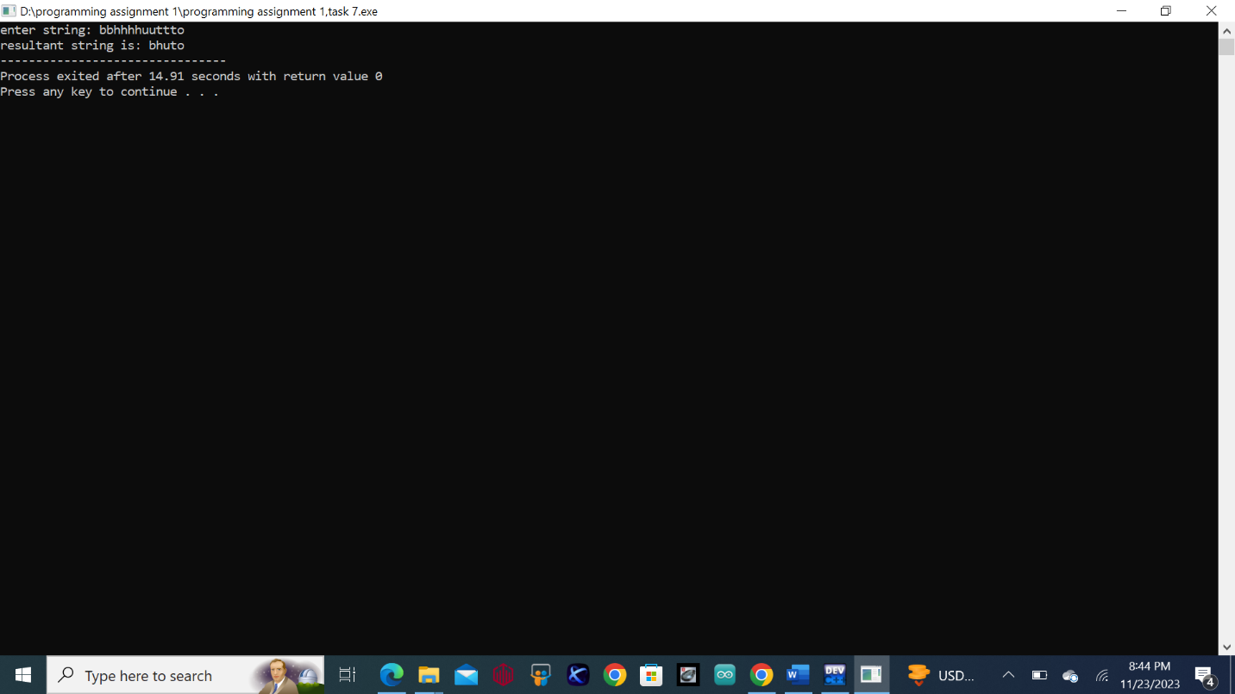

* **Task 8:**

**Statement:** Suppose an integer array a[5] = {1,2,3,4,5}. Add more elements to it and display them in C++ **Solution:**

**Code:**

#include<iostream>

using namespace std;

int main(){

int arr1[5]={1,2,3,4,5},arr2[12];

cout<<"The given array is: "<<endl;

for(int i=0;i<5;i++){

cout<<arr1[i]<<" ";

}

cout<<endl;

for(int i=0;i<5;i++){

arr2[i]=arr1[i];

}

cout<<"Enter new elements: "<<endl;

for(int j=5;j<12;j++){

cin>>arr2[j];

}

cout<<"The resultant array is: "<<endl;

for(int k=0;k<12;k++){

cout<<arr2[k]<<" ";

}

return 0;

}

**C++ file:**





**Output:**

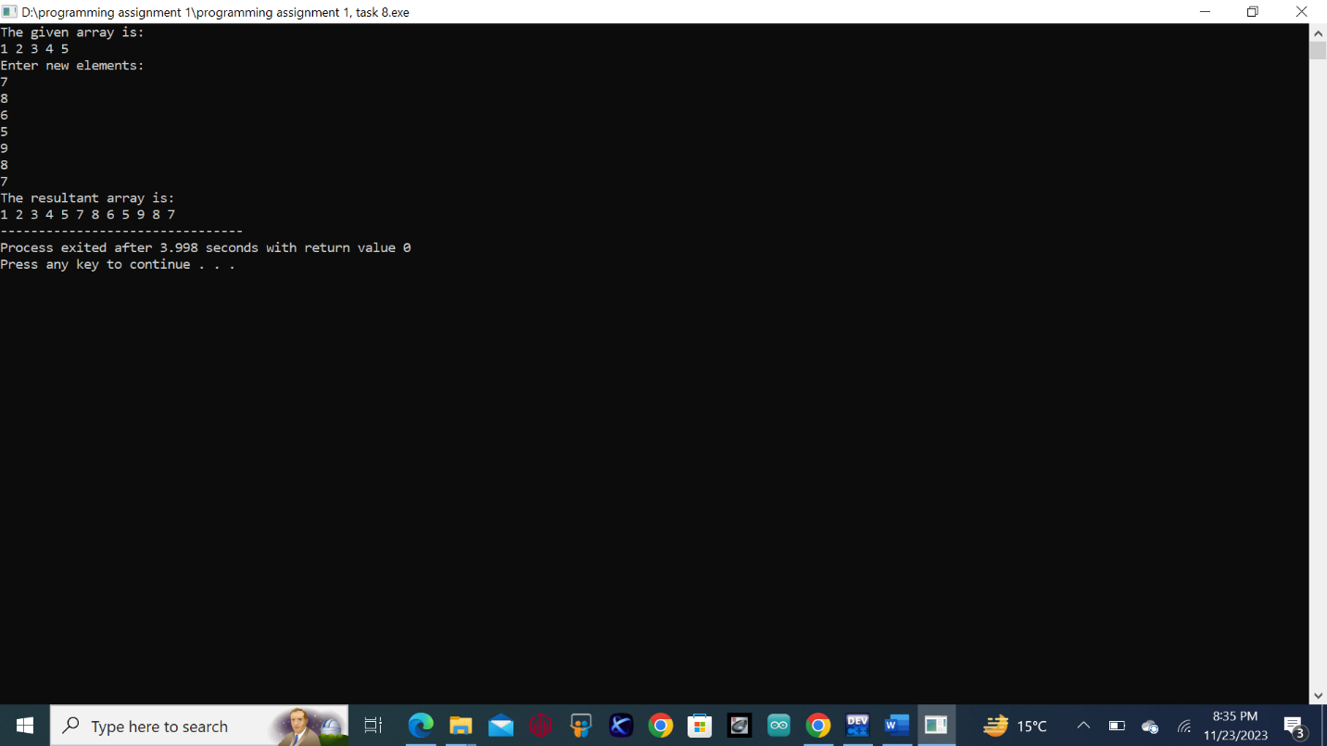

* **Task 9:**

**Statement:** Given an integer array and an integer X. Find if there’s a triplet in the array which sums up to the given integer X **Solution:**

**Code:**

#include <iostream>

using namespace std;

int main(){

int x,y=0,fop,n;

int arr[n];

cout<<"Enter The Number Of Elements: "<<endl;

cin>>n;

cout<<"Input the Array: "<<endl;

for(int i=0;i<=n-1;i++){

cin>>arr[i];

}

cout<<"The Array is: "<<endl;

for(int j=0;j<=n-1;j++){

cout<<arr[j]<<" ";

}

cout<<endl;

cout<<"Enter The Number equal to Sum of Three Numbers: "<<endl;

cin>>fop;

cout<<"The Triplet:"<<endl;

for(int j=0;j<=n-1;j++){

for(int k=k+1;k<n-1;k++){

for(int u=k+1;u<n-1;u++){

x=arr[j]+arr[k]+arr[u];

if(x==fop){

cout<<"{ "<<arr[j]<<" , "<<arr[k]<<" , "<<arr[u]<<" }"<<endl;

y=1;

}

}

}

}

return 0;}

**C++ file:**





**Output:**

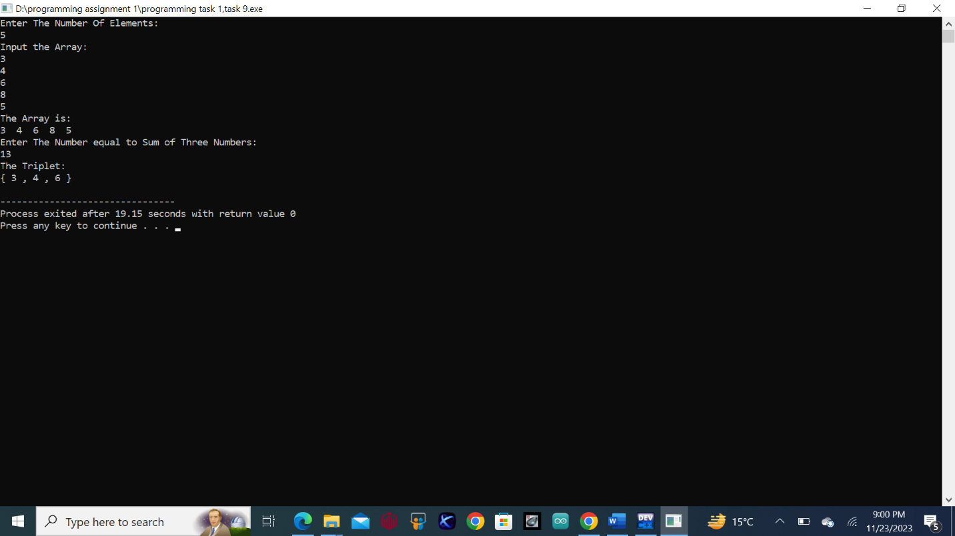

* **Task 10:  
  Statement:**

Implement Bubble Sort on an array of 6 integers.

**Solution:**

**Code:**

#include<iostream>

using namespace std;

int main(){

int num,arr[6];

cout<<"enter the required six elements in the array"<<endl;

for(int i=0;i<6;i++){

cin>>arr[i];

}

cout<<"the original entered elements in array are "<<endl;

for(int j=0;j<6;j++){

cout<<arr[j]<<" ";

} cout<<endl;

for(int k=0;k<5;k++){

for(int f=0;f<5-k;f++){

if(arr[f]>arr[f+1]){

num=arr[f];

arr[f]=arr[f+1];

arr[f+1]=num;

}

}

}

cout<<"the bubble sort of the entered six elements arrays is ";

for(int m=0;m<6;m++){

cout<<arr[m]<<" ";

}

return 0;

}

**C++ file:**





**Output:**

